

## PROJECT REPORT ON

**BOOK ANALYSIS AND RECOMMENDATION SYSTEM**

### SUBMITTED BY

GAURI GHUGE [53]

VISHAKHA NAYAK [54]

ZENITH SHAH [55]

NIYATI DAREKAR [56]

### GUIDED BY

Mr. SANJAY WANKHEDE

DEPARTMENT OF COMPUTER ENGINEERING 2021-2022



**CERTIFICATE OF APPROVAL OF PROJECT**

This is to certify that, Mr. – Kapil Bhavnani, Vaishnavi Bidoo, Yash Brid, Prem Chawla Roll No. – 29, 30, 31, 32 of VI Semester Diploma in Computer Engineering have completed the term satisfactorily in Industrial Project Development for academic year 2020-2021 as prescribed in the MSBTE curriculum.

Place: Chembur, Mumbai. Enrollment No: 180040189 1800040190

1800040191

1800040192

Date: Exam No:

Seal of Institutio

Principal IC. Head of Department

Project Guide Examiner

We would like to thank all those people who helped us in successful completion of the project “Book Analysis and Recommendation System”

We would like to thank **Mr. Vikrant Joshi**, Principal of V.E.S Polytechnic for his immense support and motivation.

We would like to thank **Mr. Sanjay Wankhade**, IC.Head of the Department, Computer Engineering of V.E.S Polytechnic, for his guidance. We are whole-heartedly thankful to him for giving us his valuable time & attention and for providing us a systematic way for completing our Project in time.

We would like to thank **Ms. Meena Talele**, our project guide for his guidance. We have learnt so many things from him and he motivated us and strengthened our confidence in doing the thesis. We express our deepest gratitude for his valuable suggestions and constant motivation that greatly helped the project work to successfully complete. Throughout the project work, his useful suggestions, constant encouragement has given us a right direction and shape to our learning.

We would also thank all the faculty members who have been a constant source and encouragement during the entire course of our study in this college.

## TABLE OF CONTENT

| **Sr. No.** | **Topic** | **Page No.** |
| --- | --- | --- |
| **1** | **INTRODUCTION** | **01** |
| 1.1 | Overview of the project | 02 |
| 1.2 | Existing System | 02 |
| 1.3 | Limitations of Existing System | 02 |
| 1.4 | Proposed System | 03 |
| 1.5 | Advantages of Proposed System | 03 |
| **2** | **SYSTEM DEVELOPMENT** | **04** |
| 2.1 | System Specification | 05 |
| 2.2 | Technology Used | 06 |
| **3** | **FEATURES** | **9** |
| **4** | **DESCRIPTION OF ALGORITHIM / LOGIC** | **11** |
| 4.1 | TF-IDF, Cosine Similarity | 12 |
| 4.2 | Sparse Matrix, K-Nearest Neighbors | 13 |
| 4.3 | Sentiment Analysis | 14 |
| **5** | **USE CASE DIAGRAM** | **15** |
| **6** | **FLOWCHART** | **17** |
| **7** | **ALGORITHM** | **21** |
| **8** | **GANTT CHART** | **23** |
| **9** | **SNAPSHOTS** | **27** |

| **10** | **REFERENCES** | **35** |
| --- | --- | --- |
| **11** | **CODE** | **37** |
| **12** | **TESTING** | **50** |
| 12.1 | Testing Details | 51 |
| 12.2 | Test Cases | 54 |
| **13** | **BUG REPORT** | **55** |
| **14** | **CONCLUSION** | **58** |
| **15** | **FUTURE SCOPE** | **60** |
| **16** | **RESEARCH PAPER** | **62** |

**LIST OF FIGURES**

| **Sr.**  **No.** | **Figure**  **No.** | **Name of Figure** | **Page**  **No.** |
| --- | --- | --- | --- |
| 1 | 4.1.1 | Recommendation using TF-IDF | 12 |
| 2 | 4.2.1 | Recommendation using KNN | 13 |
| 3 | 5.1 | Use Case Diagram | 16 |
| 4 | 6.1 | Flowchart for General Workflow | 18 |
| 5 | 6.2 | KNN Flowchart | 19 |
| 6 | 6.3 | TF-IDF Flowchart | 20 |
| 7 | 8.1 | GANTT Chart - Table of Activities | 24 |

| 8 | 8.2 | GANNT CHART 1 | 25 |
| --- | --- | --- | --- |
| 9 | 8.3 | GANNT CHART 2 | 25 |
| 10 | 8.4 | GANNT CHART 3 | 26 |
| 11 | 8.5 | GANNT CHART 4 | 26 |
| 12 | 9.1 | Landing page with about us section | 28 |
| 13 | 9.2 | Distribution of Books section | 29 |
| 14 | 9.3 | Trending Books | 29-30 |
| 15 | 9.4 | Authors section | 30 |
| 16 | 9.5 | Users section | 31 |
| 17 | 9.6 | Books and Authors details section | 32 |
| 18 | 9.7.1 | Polarity and Subjectivity of review | 33 |
| 19 | 9.7.2 | Ratio of positive, negative and neutral reviews | 33 |
| 20 | 9.8.1 | Content based Recommendation | 34 |
| 21 | 9.8.2 | Collaborative Recommendation | 34 |
| 22 | 16.1 | Yash Brid’s Certificate | 69 |
| 23 | 16.2 | Prem Chawla’s Certificate | 69 |
| 24 | 16.3 | Kapil Bhavnani’s Certificate | 70 |
| 25 | 16.4 | Vaishnavi Bidoo’s Certificate | 70 |

## ABSTRACT

With each passing year, more number of books are published. We have always considered the magical persona, and the impact, books seem to hold, and in this project we analyze what kind of books really interests people into reading. The sole purpose of this project is to provide an in-depth analysis on data related to books and recommend new books to the users based on their choices. So by developing this recommendation system, we group together the books that are similar in some aspect and provide new recommendations to the users.

CHAPTER 1

# INTRODUCTION



## Chapter 1

**INTRODUCTION**

### OVERVIEW OF THE PROJECT

The basic idea of this project is to analyze different attributes of a book and find the relation between these attributes and recommend books to the users. It analyzes how these attributes affect the book’s rating or book’s popularity, what features have more importance and so on. It also analyzes and visualizes the sentiments of user reviews. In order to do so, an in-depth EDA process is performed on the data to get efficient results. For the UI purpose, Django framework has been used to present the visuals in an interactive manner

### EXISTING SYSTEM

With each passing year, more number of books are published. We have always considered the magical persona, and the impact, books seem to hold, and in this project we analyze what kind of books really interests people into reading.

In contrast to this, the internet nowadays provides plentiful resources online for people to access. For example, Goodreads is an American website, which has a vast collection of books, reviews, quotes, etc. But even though the size or the range of the available resources or information is increased, a new problem has emerged where people have a hard time choosing the books that they actually want to read. So, this is where the role of recommendation system comes in, and it turns out to be helpful for the users, as it saves a lot of their time that would otherwise have been spent on deciding which book to read next.

### LIMITATIONS OF EXISTING SYSTEM

* + - Confusion about what to read next.
    - Not proper analysis on books .
    - Not proper analysis on authors.
    - Time consuming.



### PROPOSED SYSTEM

This project gives us a deep analysis on books and user datasets. These are multiple datasets containing information related to books and user rating such as book title, authors, language, average rating, publishing year, etc.

The datasets had been read into pandas data frames and had been combined together, data cleaning has been done on the combined datasets. After the cleaning process, the EDA process has been performed to uncover the patterns, insights and anomalies within the data. Through the EDA process we get the answers to, which are the top most rated/popular books over the years, top most rated/popular authors, the rating and language distribution of the books, authors overall performance, etc.

After data visualization, a recommendation system is built. It provides two types of recommendation, first, content based recommendation using TF-IDF and cosine similarity matrix, and second, collaborative recommendation, based on how similar are your preferences to the other users, and then recommend the books they have liked or rated. Lastly, sentiment analysis has been performed to interpret and classify the emotions related to the project topic.

### ADVANTAGES OF PROPOSED SYSTEM

The whole purpose of this system is to make reading books easier for the readers, and recommend books with just a click. To present visualizations regarding reviews, books, authors, such as trending books and authors. With the help of the visualization, Book-keeper can decide which books to keep in shop based on popularity, so that people ca buy it.



CHAPTER 2 **SYSTEM DEVELOPMENT**



## Chapter 2

**SYSTEM DEVELOPMENT**

### SYSTEM SPECIFICATION

* + 1. Hardware Requirements (Minimum of the hardware required)
       - Processor: Intel core i3
       - RAM: 4GB RAM
       - Hard Disk: 20GB
    2. Software Requirements (Any higher version will do)
       - Operating System: Windows XP or later
       - Web Browser
       - Python.
       - Django.
       - Pandas.
       - Numpy.
       - Plotly.
       - Scikit-Learn
       - TextBlob.
       - Jupyter Notebook.
       - Chart.js



### TECHNOLOGY USED

* + 1. **Python**

What is Python?

Python is an interpreted, object-oriented, high-level programming language with dynamic semantics. Its high-level built in data structures, combined with dynamic typing and dynamic binding, make it very attractive for Rapid Application Development, as well as for use as a scripting or glue language to connect existing components together. Python's simple, easy to learn syntax emphasizes readability and therefore reduces the cost of program maintenance. Python supports modules and packages, which encourages program modularity and code reuse. The Python interpreter and the extensive standard library are available in source or binary form without charge for all major platforms, and can be freely distributed

### Django

What is Django?

Django is a free and open-source web application framework written in Python. It is used for rapid web development and clean, pragmatic design. It is built by experienced developers to make repetitive tasks easier, so we can focus on writing apps instead of reinventing the wheel.

### Pandas

What is Pandas?

Pandas is a software library for python programming language, for data manipulation and analysis. It provides a fast and efficient way to manage and explore data, handling missing data, cleaning up data, merging and joining datasets, etc. It provides essential data structures like series, dataframes , etc.



### Numpy

What is Numpy?

NumPy is a python library, adding support for large, multi-dimensional arrays and matrices, along with a large collection of high-level mathematical functions to operate on arrays.

### Plotly

What is Plotly?

Plotly is an interactive and open-source plotting library for python that supports over 40 unique chart types covering a wide range of statistical, financial, geographic, scientific and 3- dimensional use-cases.

### Scikit-Learn

What is Scikit-Learn?

Scikit-Learn is a free software machine learning library for the python programming language, featuring various classification, regression and clustering algorithms including support vector machines, random forests, etc. and is designed to interoperate with python numerical and scientific libraries.

### TextBlob

What is TextBlob?

TextBlob is a python library for pre-processing textual data and provides a simple API for diving into common NLP tasks such as, part-of-speech tagging, noun phrase extraction, sentiment analysis, classification and much more.



### Jupyter Notebook

What is Jupyter Notebook?

Jupyter notebook is an open source web-application that supports interactive data science and scientific computing. It is used for Data Collection, Data Cleaning, Data visualization, Statistical models, Machine Learning and much more. It supports a variety of programming languages including python, R, scala, etc.

### Chart-js

What is Chart-js?

Chart.js is a free open-source JavaScript library for data visualization, which supports 8 chart types: bar, line, area, pie (doughnut), bubble, radar, polar, and scatter. Chart.js renders in HTML5 canvas and is widely covered as one of the best data visualization libraries. It is the second most popular JS charting library.



CHAPTER 3

# FEATURES



## Chapter 3

**Features**

This website will help user to rent a car at lower price.To book a car user just have to Login into the website, Select a car as per requirement, Fill the car pick up date ,time and some important details. In the last user have to do the online payment.

User can book a car just by sitting in home.User can use this system and save a lot of time, money & efforts because of the features provided by our system which is listed below:

1. User can see available cars.

2. User can see the car distribution.

3. User can get car details.

4. User can see car price with offers and without offers.

5. User can get amazing discounts.

6. User can get good cars with good price.

7. User can get collaborative car recommendation.

8. Cost Efficient.



CHAPTER 4 **DESCRIPTION OF ALGORITHMS/**

# LOGIC



## Chapter 4

**Description of Algorithms/ Procedure/ Logic Used**

### TF-IDF, Cosine Similarity:

* For the recommendation system, TF-IDF with cosine similarity model from python’s Scikit- learn library is used, for content-based recommendation. Term Frequency-Inverse Document Frequency, evaluates a word in the document and calculates the weight of the word according to its importance in the document. It calculates the frequency of the word, and the more frequently the word appears, the larger its weight will be. It also weighs the word inversely to the frequency of the word across the entire dataset, which means the words such as, ‘is’, ‘are’, ‘by’, ‘the’, ‘a’, etc. which are most likely to show up in every book, but are not of any user for our recommendation system, will be weighed less than the other unique words in the document.
* For calculating the cosine similarity we need the word count of each word in the document, so here the TfidfVectorizer() function is used to generate a sparse matrix. This is done by first removing the stopwords from the documents and then creating the matrix by fitting and then transforming the data using tfidf.fit_transnform(). After generating the matrix by TF-IDF, cosine similarity is calculated by linear_kernel() provided by the Scikit Learn.
* In figure 4.1.1 you can see that, how TF-IDF algorithm will work in our project.

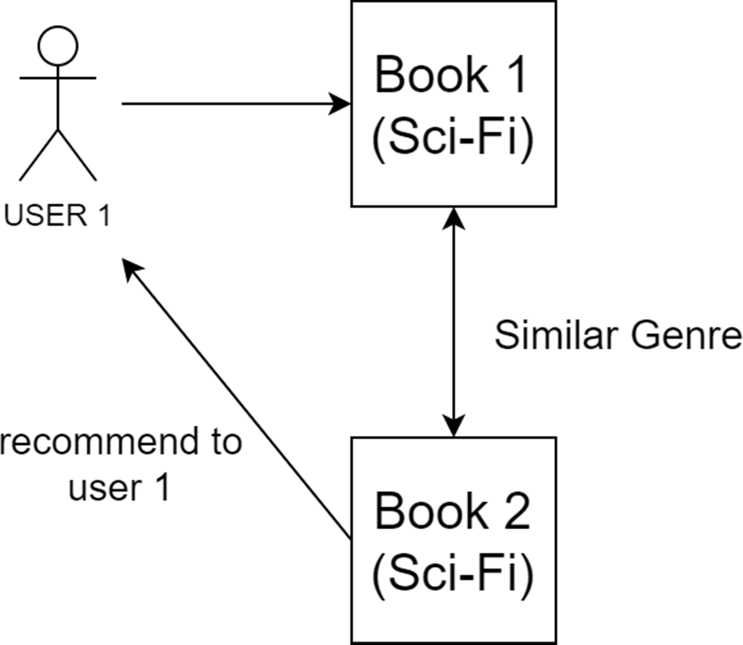

**Fig 4.1.1 Recommendation using TF-IDF**



### Sparse Matrix, K-Nearest Neighbors:

* The K-nearest neighbor is a simple, easy to implement supervised ML algorithm that can be used to solve both regression and classification problems. It assumes that similar things exist in close proximity. In other words similar things are near to each other. It captures the idea of similarity sometimes called distance, proximity or closeness with some mathematics of calculating the distance between points on a graph. Straight line distance, also called Euclidean distance is a popular and familiar choice.
* For the collaborative recommendation system, based on similarity between the user profiles, first the pivot table is generated with the book_title, user_id and ratings attributed from the dataset. After creating the pivot table which is basically a dense matrix, it is converted into a sparse matrix using the SciPy’s csr_matrix() function. For the recommendation, Scikit-learn’s K-Nearest Neighbors model with brute force approach is used. After creating the model, it is trained on the sparse matrix.
* In figure 4.2.1 you can see that, how KNN algorithm will work in our project.

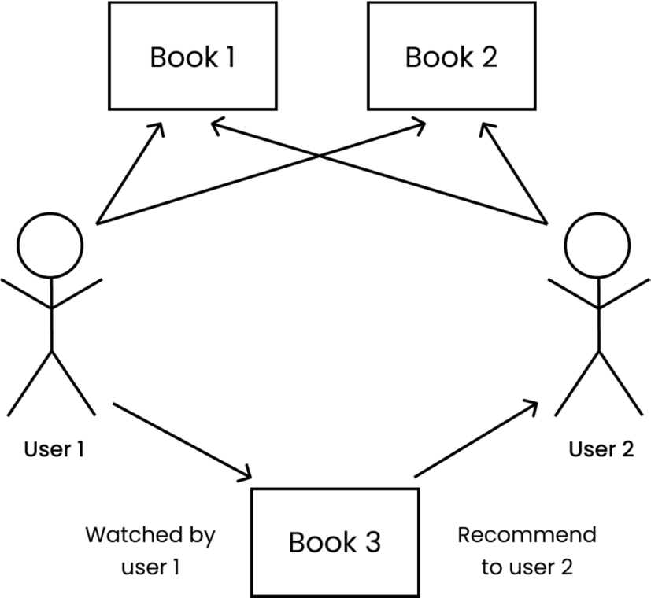

**Fig 4.2.1 Recommendation using KNN**



### Sentiment Analysis:

* Sentiment analysis (or opinion mining) is a natural language processing technique used to determine whether data is positive, negative or neutral. Sentiment analysis is often performed on textual data to help businesses monitor brand and product sentiment in customer feedback, and understand customer needs.
* For sentiment analysis, a text reviews dataset is used. Cleaning process is performed by using the re library. Polarity and Subjectivity are calculated and stored in new columns of the dataframe. The percentage of the positive, negative and neutral reviews is calculated based on the polarity score, that is, if the polarity is greater than 0, the review has positive sentiment, if it is less than 0, then the review has negative sentiment, otherwise the review is neutral.



CHAPTER 4 **USE CASE DIAGRAM**



## Chapter 4

**USE CASE DIAGRAM**

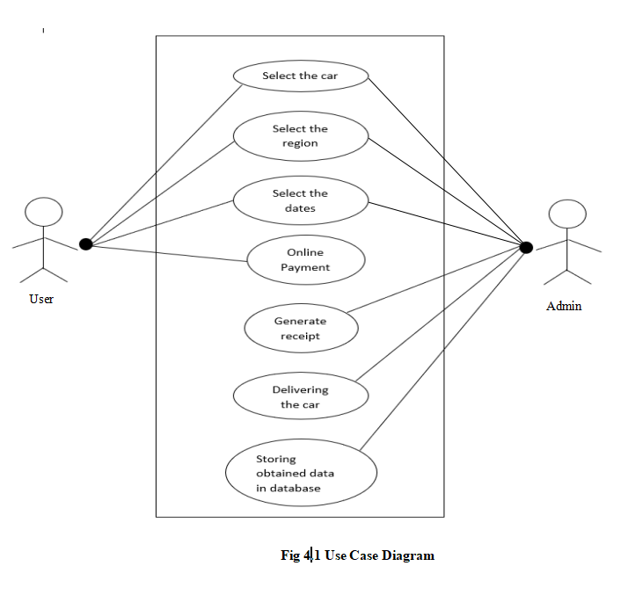



CHAPTER 6

# FLOWCHART



## Chapter 6 FLOWCHART

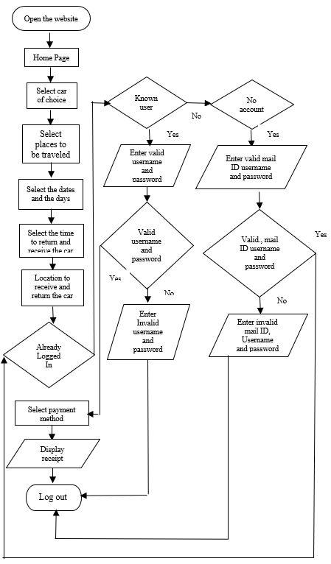

CHAPTER 7

# ALGORITHM



## Chapter 7 ALGORITHM

**Basic workflow**

The Algorithm for user login:

1. Open the website.
2. Log-in to user account. If the user doesn’t have an account, then sign up.
3. Select a car of choice.
4. Select the place to be travelled.
5. Select the number of days and dates to be travelled.
6. Select the time to receive and return the car.
7. Select a location for the car to be delivered.
8. Select the payment mode i.e. credit/debit card or Cash On Delivery.
9. A print of the receipt to be acquired by the user.
10. Log-out from the website.

CHAPTER 8

# GANTT CHART



## Chapter 8 GANTT CHART

* A **Gantt Chart** is a type of bar chart that illustrates a project schedule.
* Gantt charts illustrate our start and finish dates of the terminal elements and summary elements of a project.
* It is one of the most popular and useful ways of showing activities (tasks or events) displayed against time.

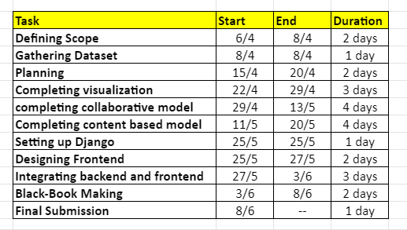

**Fig 8.1 – Table of Activities**



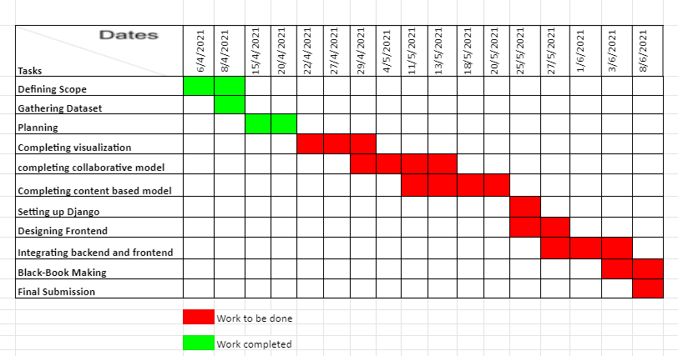

**Fig 8.2 – GANTT CHART 1**

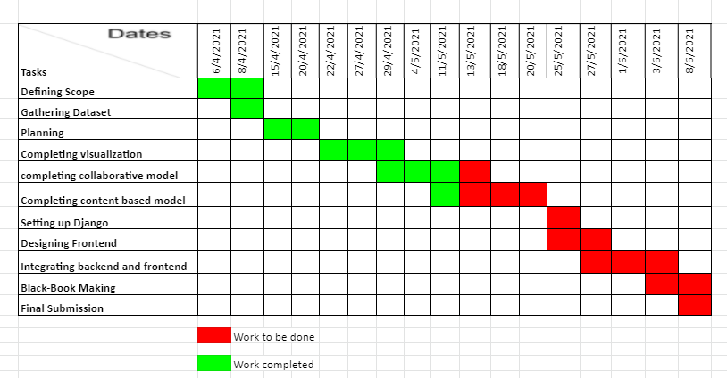

**Fig 8.3 – GANTT CHART 2**



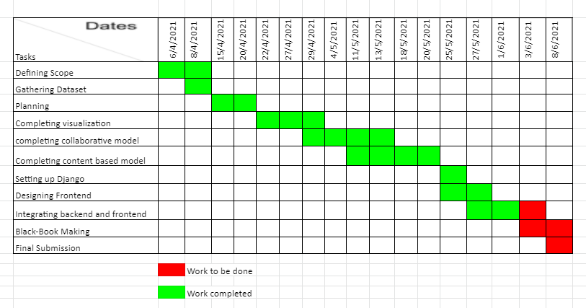

**Fig 8.4 – GANTT CHART 3**

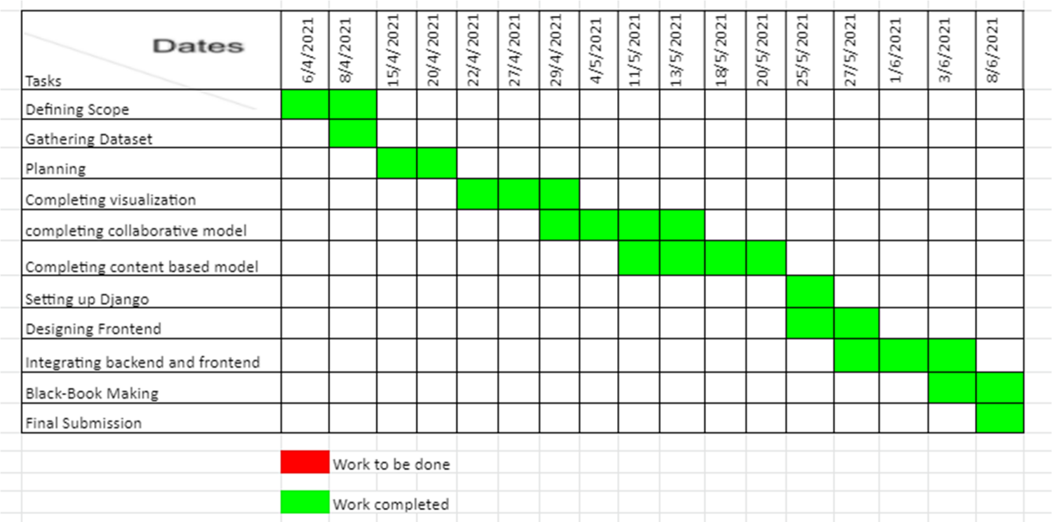

**Fig 8.5 – GANTT CHART 4**



CHAPTER 9

# SNAPSHOTS



## CHAPTER 9

**SNAPSHOTS**

* + This is the landing page for our Web-Application along with About us section.

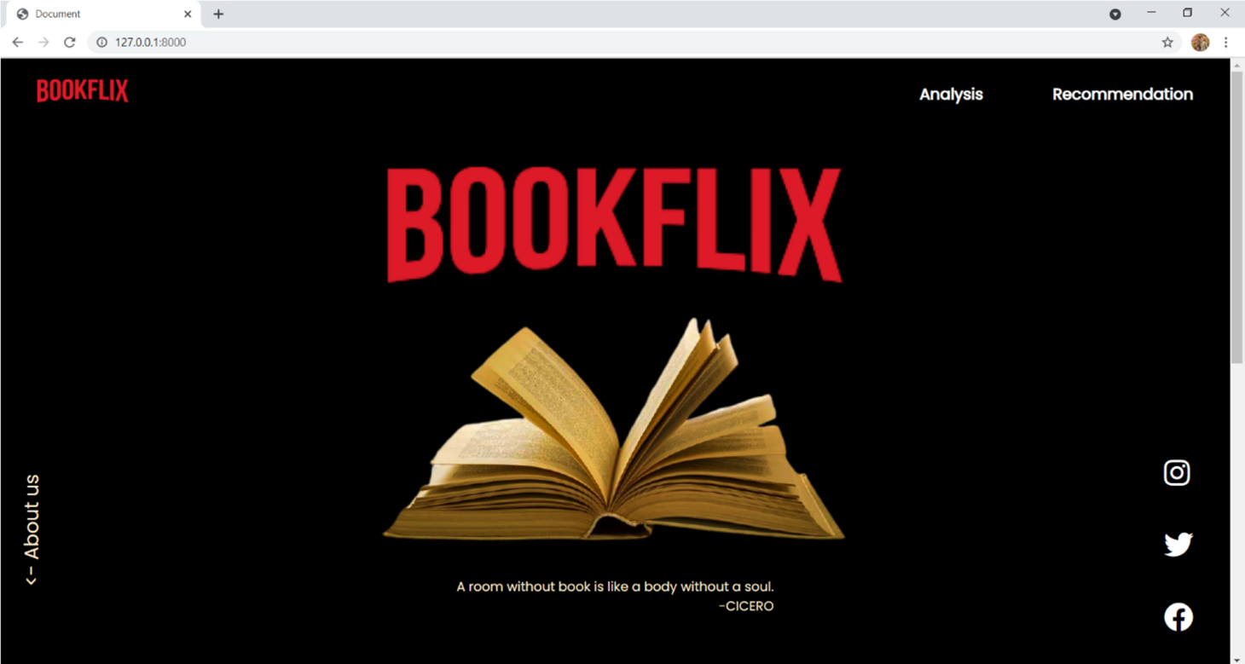

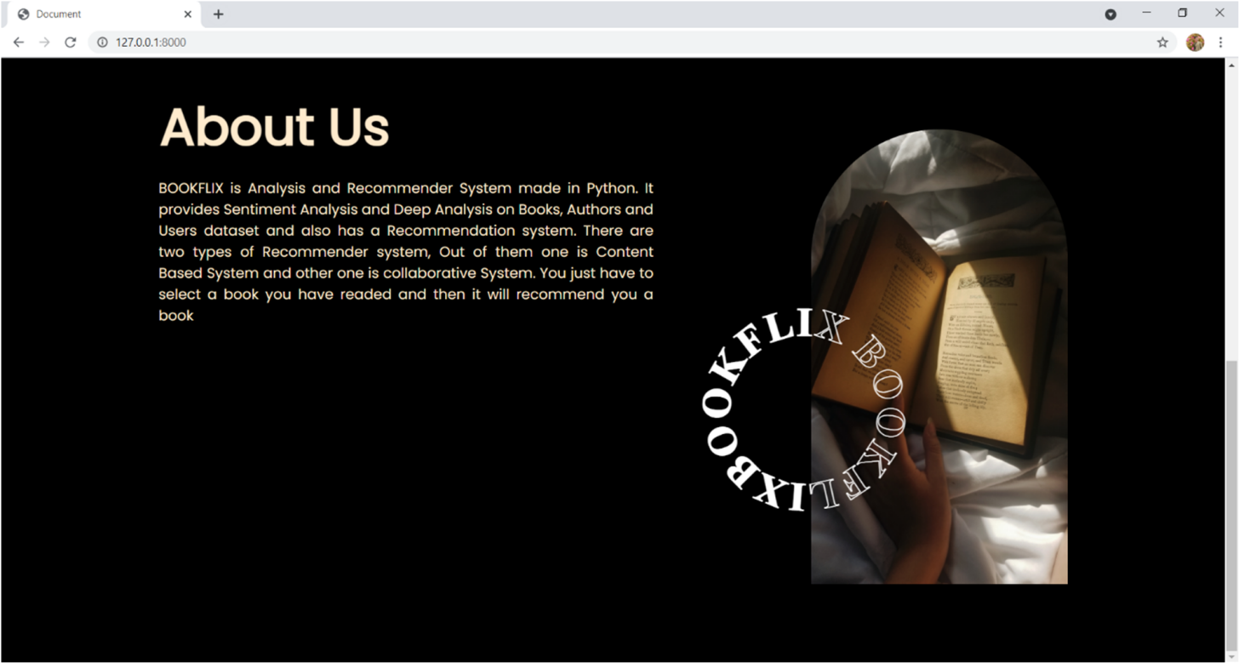

**Fig 9.1 – Landing Page with About Us section**



* + Here we can see the distribution of books across ratings, language and the book published over the years. So, we can tell that most of the books received ratings between 4-5, almost around 7500 books are in English language and 2011 was the year in which highest number of books were published.

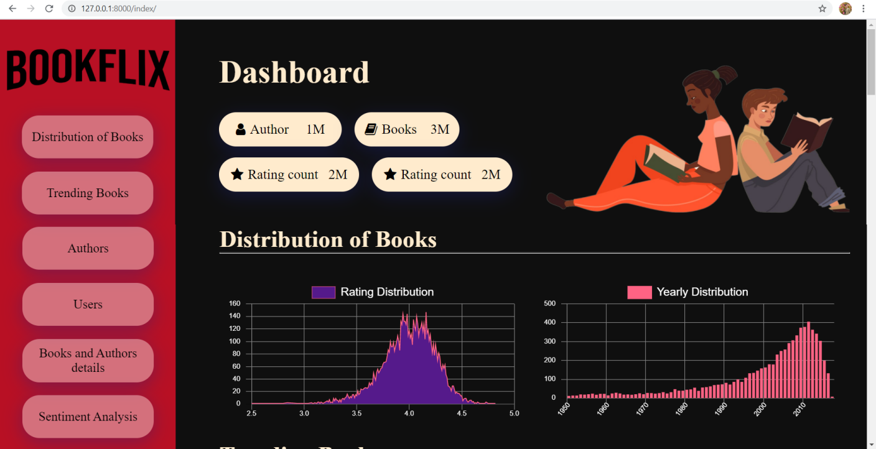

**Fig 9.2 – Distribution of Books section**

* + Here the users can view the trending books based on popularity and rating.

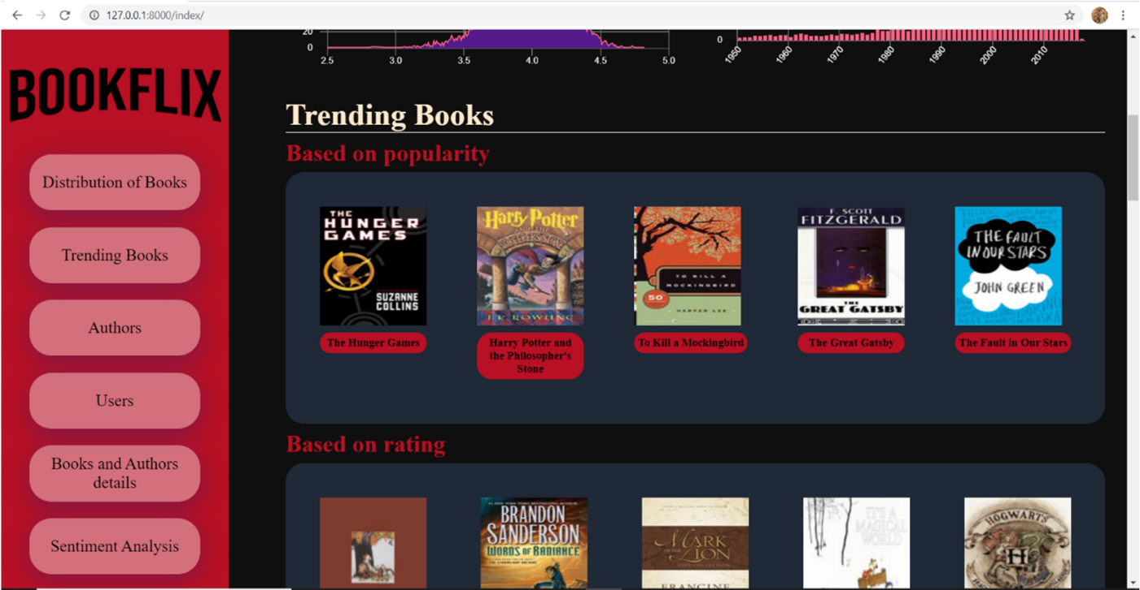

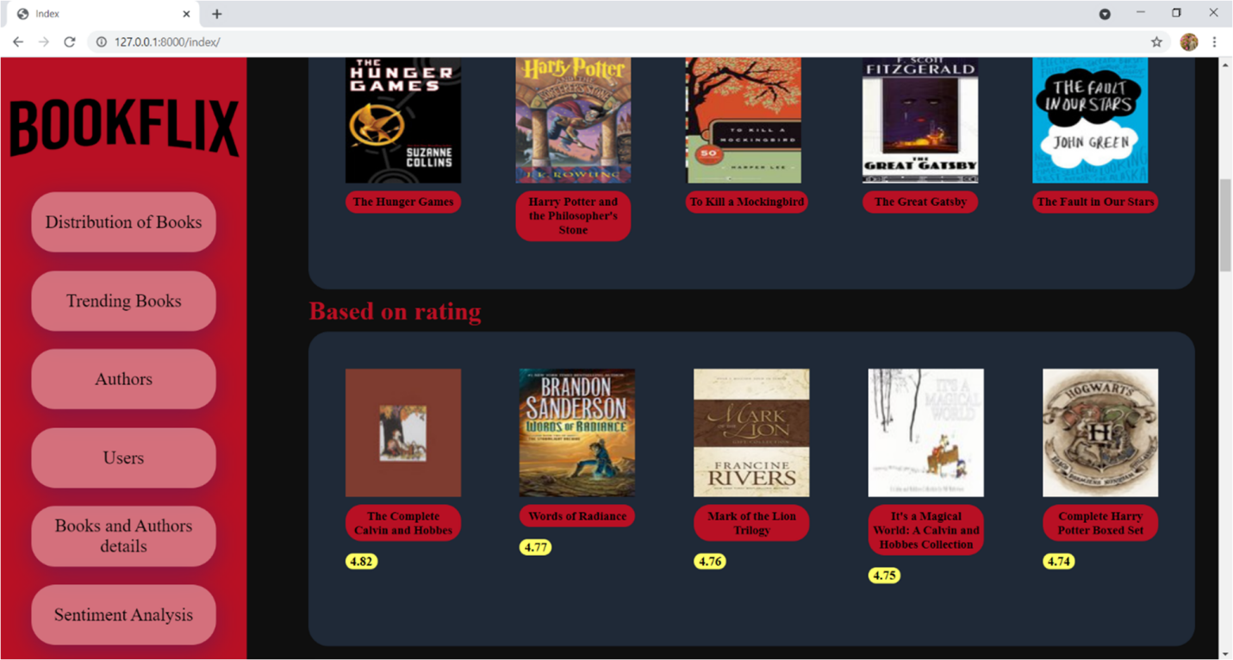

**Fig 9.3 – Trending Books section**

* + Here, we can see the authors with the most books published and the authors with the highest ratings received for all the books they’ve published

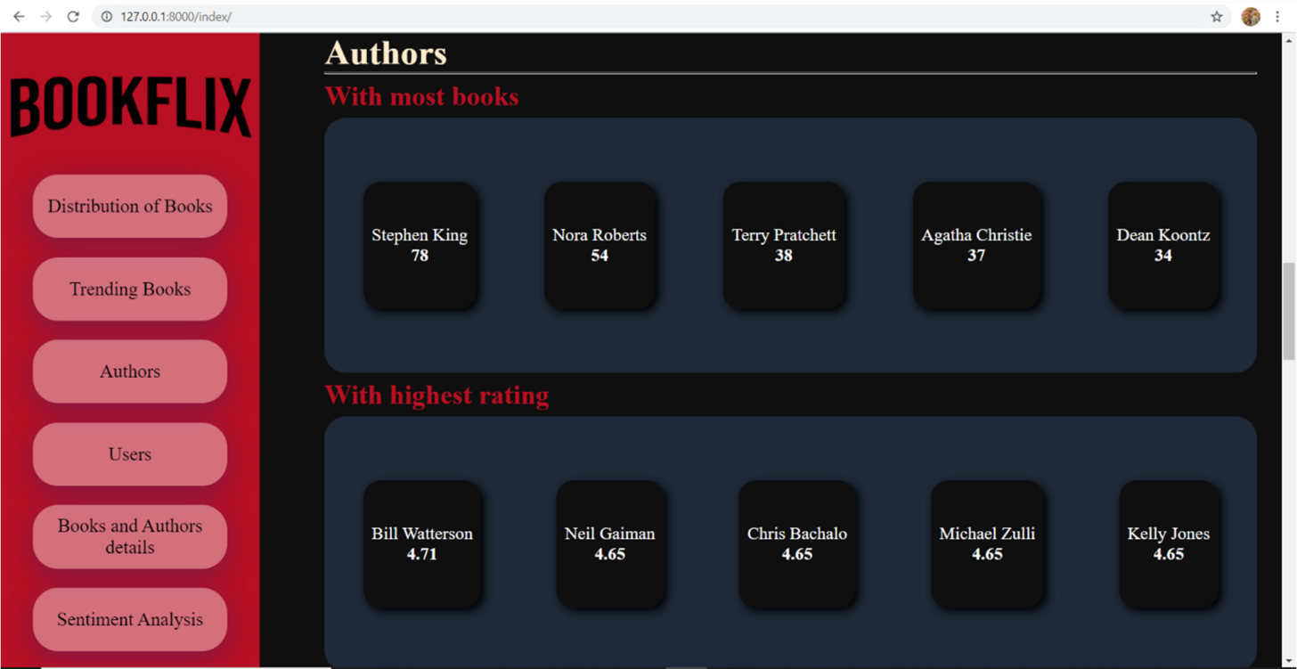

**Fig 9.4 – Authors section**



* + In the users tab we can see the users details, like the age distribution, user state, country, location. We can see that 31-50 is the age group that is very active among all the other age groups. Similarly we can see the top State, city, Country from which the users are active.

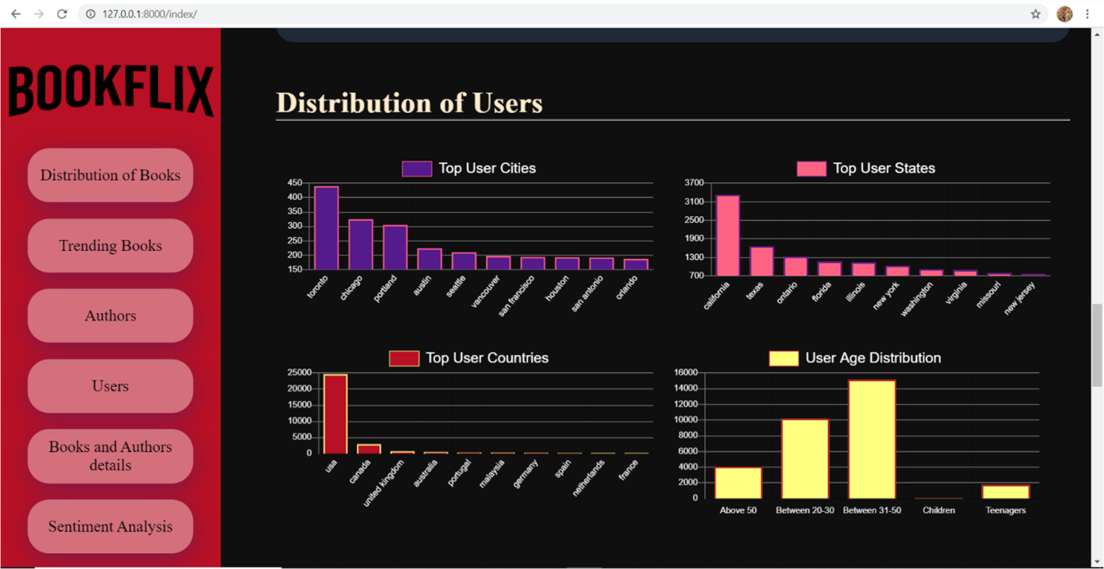

**Fig 9.5 – Users section**



* + In this tab we can see the book details and the author details for that particular book. In book detail we can see the average rating of the book, the author of the book, it’s language, publishing year, and total ratings received for that book. For author details we can view the most popular books of the author based on the rating counts, the highest rated books of the author and the overall performance of the author over the active years

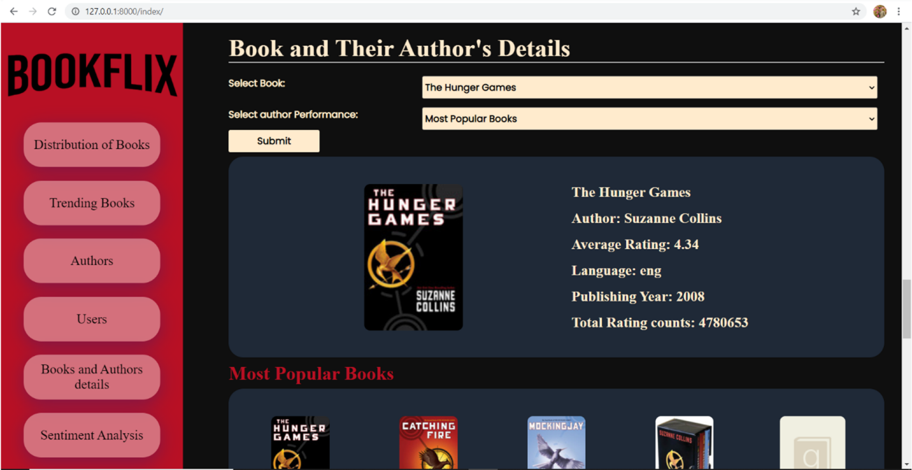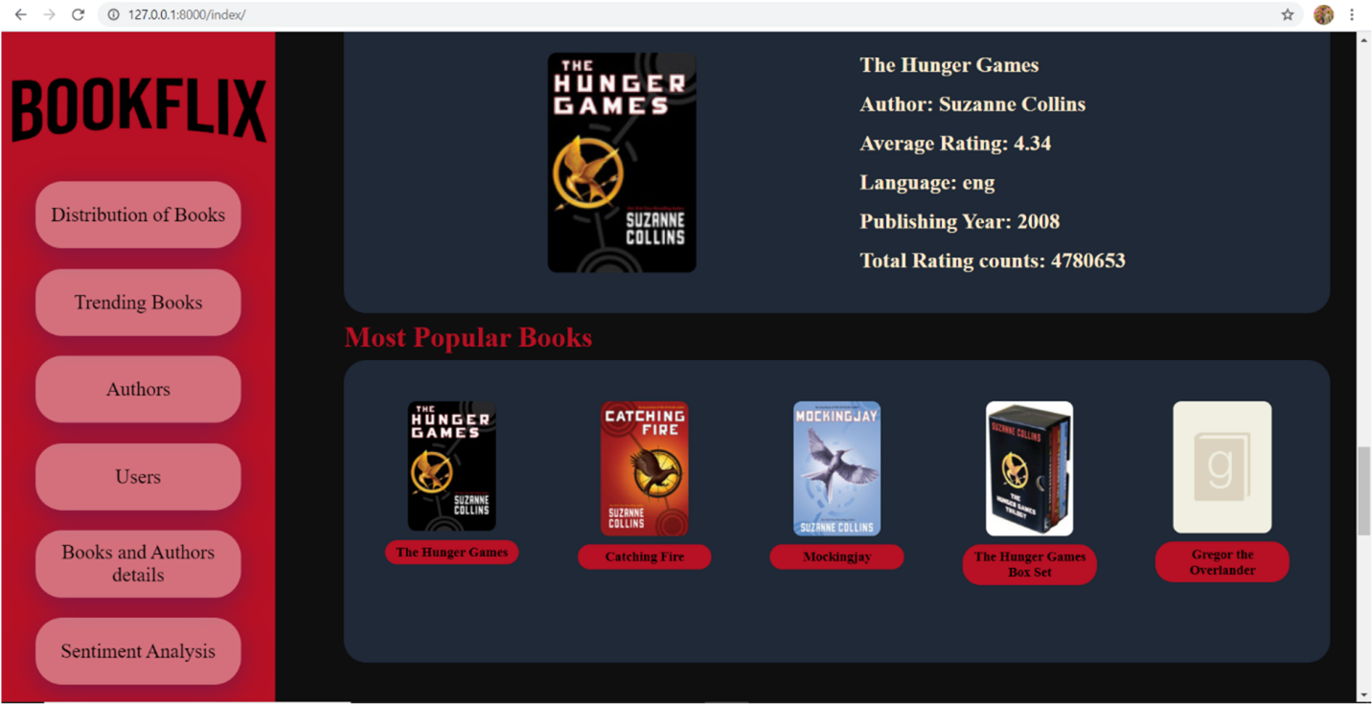

**Fig – 9.6 Books andAuthors Details section**



* + In Sentiment Analysis, we analyze the textual reviews received by the users and classify them accordingly

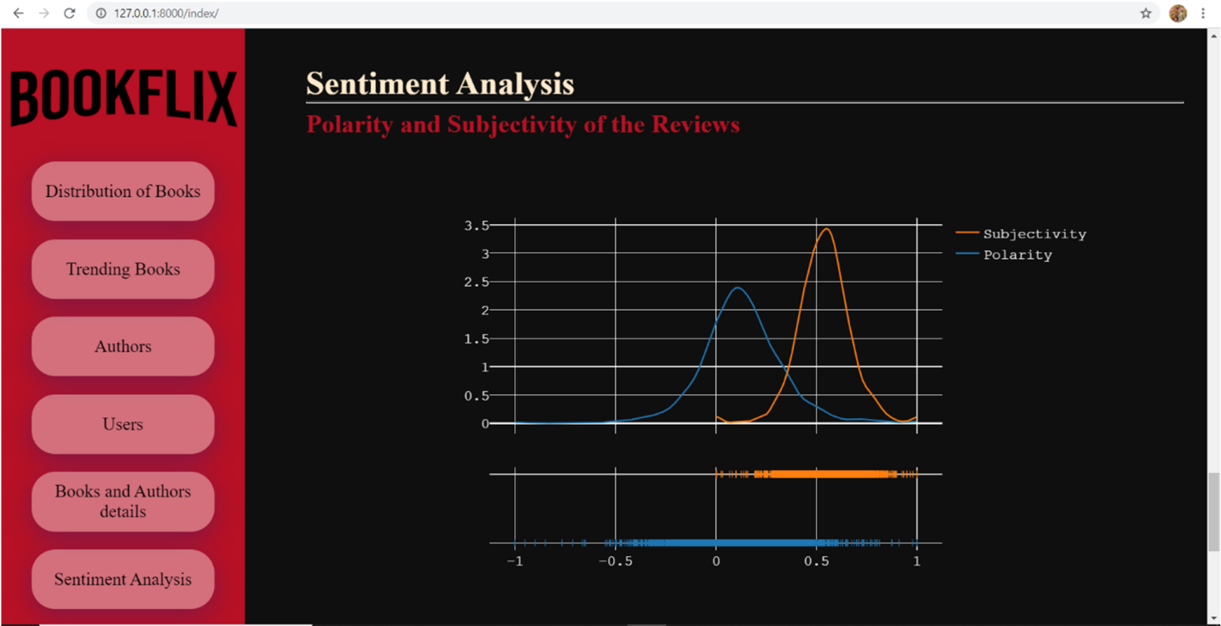

**Fig 9.7.1 – Polarity and Subjectivity of the Reviews**

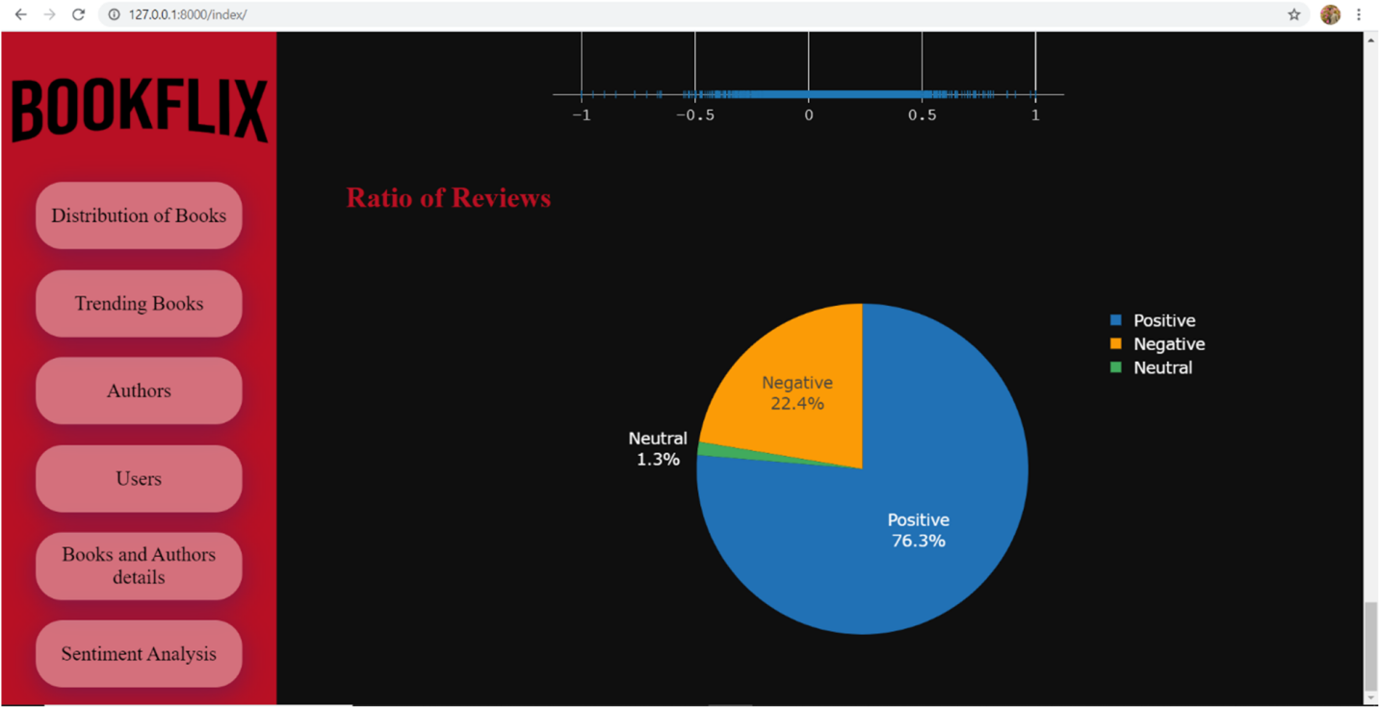

**Fig 9.7.2 – Ratio of positive, negative and neutral Reviews**



* + In the recommendation tab we can see two types of recommendations, one based on the similarity(content-based) and the other based on the user preferences(collaborative)

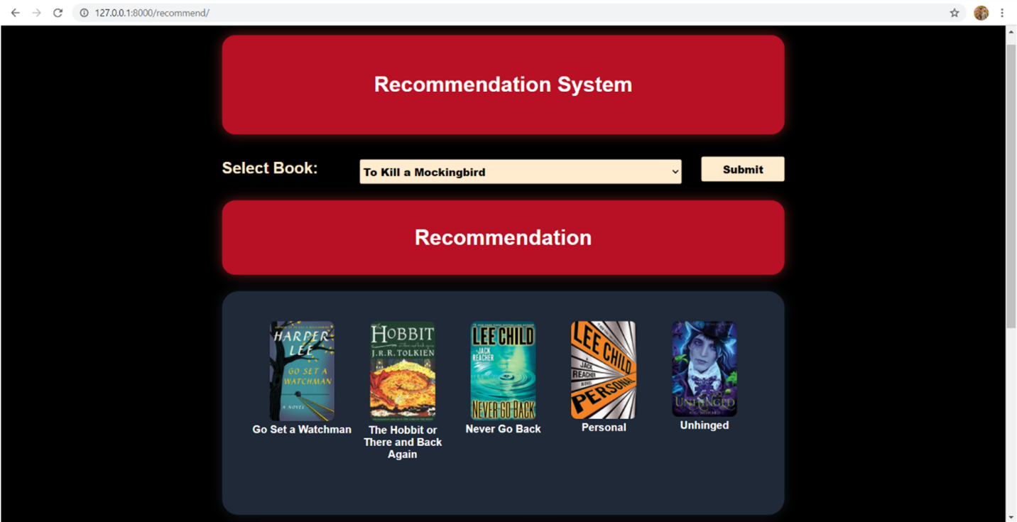

**Fig 9.8.1 – Content Based Recommendation**

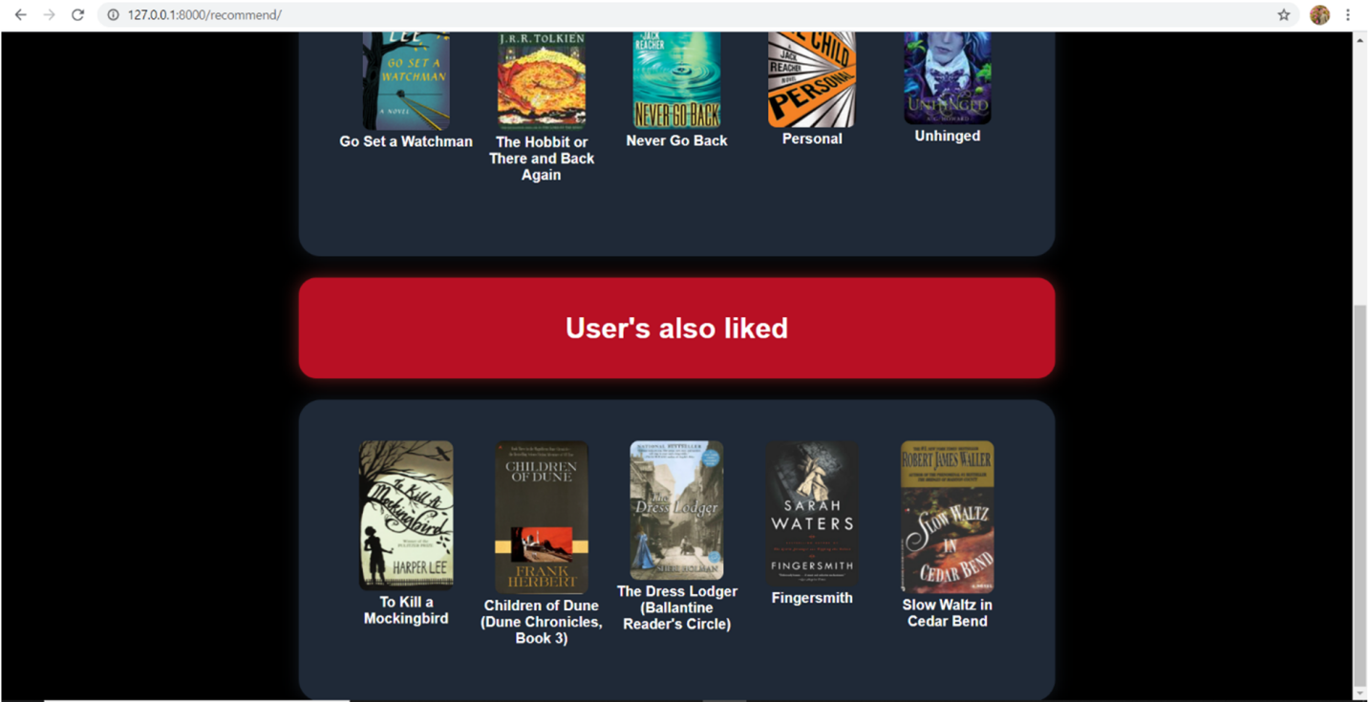

**Fig 9.8.2 – Collaborative Recommendation**



CHAPTER 10

# REFERENCES



## CHAPTER 10

**REFERENCES**

1. Deuk Hee Park, Hyea Kyeong Kim, Il Young Choi, Jae Kyeong Kim, “A literature review and classification of recommender systems research”, Volume 39, Issue 11, 2012, Pages 10059- 10072, ISSN 0957-4174
2. Brooke, Julian, Milan Tofiloski, and Maite Taboada. "Cross-linguistic sentiment analysis: From English to Spanish." Proceedings of the international conference RANLP-2009. 2009.
3. P. Turney. Thumbs up or thumbs down? Semantic orientation applied to unsupervised classification of reviews. Proc. of ACL, 2002.
4. B. Pang, L. Lee and S. Vaithyanathan. Thumbs up? Sentiment classification using Machine Learning techniques. Proc. of EMNLP, 2002.
5. Yugantshekhar, “ML- Content Based Recommender System”, geeksforgeeks.org



CHAPTER 11

# CODE



## CHAPTER 11

**CODE**

### collaborative model.py

from sklearn.neighbors import NearestNeighbors from scipy.sparse import csr_matrix

import pickle import pandas as pd

df = pd.read_csv("reco.csv")

book_pivot1 = df.pivot_table(*columns*='user_id', *index*='book_title', *values*='rating') book_pivot1.fillna(0, *inplace*=True)

book_sparse1 = csr_matrix(book_pivot1)

model = NearestNeighbors(*algorithm*='brute') *# model*

model.fit(book_sparse1)

filename = 'collaborative_model.pkl' pickle.dump(model, open(filename, 'wb'))

### sim score.py

import pickle import pandas as pd

from sklearn.feature_extraction.text import CountVectorizer, TfidfVectorizer from sklearn.metrics.pairwise import cosine_similarity



def load_data(*nrows*):

data = pd.read_csv("final_books3.csv") return data

books = load_data(10000) df = books

content_data = df[['original_title', 'authors', 'average_rating', 'image_url']] content_data = content_data.astype(str)

content_data['content'] = content_data['original_title'] + ' ' + content_data['authors'] + ' ' + cont ent_data['average_rating'] + ' ' + content_data['image_url']

content_data = content_data.reset_index()

indices = pd.Series(content_data.index, *index*=content_data['original_title']) tfidf = TfidfVectorizer(*stop_words*='english')

tfidf_matrix = tfidf.fit_transform(content_data['authors']) tfidf_matrix.shape

count = CountVectorizer(*stop_words*='english') count_matrix = count.fit_transform(content_data['content'])

cosine_sim_content = cosine_similarity(count_matrix, count_matrix) with open('sim_score.pkl', 'wb') as f:

pickle.dump(cosine_sim_content, f)

### forms.py

from django import forms



import pandas as pd import csv

def load_data(*nrows*):

data = pd.read_csv("final_books3.csv") return data

def load_data1(*nrows*):

data = pd.read_csv("reco.csv") return data

books = load_data(10000) original_data = books users = load_data1(10000) original_data1 = users

def get_my_choices():

list1 = books['original_title'].unique().tolist() list2 = books['original_title'].unique().tolist() merged_list = tuple(zip(iter(list1), iter(list2))) return merged_list

def get_list():

titles = users['book_title'].unique()

title = books[books['original_title'].isin(titles)] title1 = title['original_title'].unique()



title2 = title['original_title'].unique() merged_list = tuple(zip(iter(title1), iter(title2))) return merged_list

class UserForm(forms.Form):

field = forms.ChoiceField(*label*='Select Book', *choices*=get_my_choices())

CHOICES = (('Most Popular Books', 'Most Popular Books'),('Highest Rated Books', 'Highe st Rated Books'), ('Over The Year Performance', 'Over The Year Performance'))

authors_perf = forms.ChoiceField(*label*='Select author Performance', *choices*=CHOICES) class UserForm2(forms.Form):

select5 = forms.ChoiceField(*label*='Select Book', *choices*=get_list())

### views.py

from django.shortcuts import render from django.http import HttpResponse

from .forms import UserForm, UserForm2 import pandas as pd

import numpy as np import csv

from plotly.offline import plot import plotly.figure_factory as ff import plotly.graph_objs as go import pickle



from scipy.sparse import csr_matrix def load_data(*nrows*):

data = pd.read_csv("final_books3.csv") return data

def load_data1(*nrows*):

data = pd.read_csv("reco.csv") return data

def load_data2(*nrows*):

data = pd.read_csv("sentiments.csv") return data

def index(*request*):

books = load_data(10000) original_data = books users = load_data1(10000) original_data1 = users

reviews = load_data2(10000) original_data2 = reviews

cnt_srs = books["average_rating"].value_counts() cnt = cnt_srs.sort_index()

cnt_srs1 = books["language_code"].value_counts()[:5] df_year = books[books['original_publication_year'] >= 1950]



cnt_year = df_year["original_publication_year"].value_counts() cnt_y = cnt_year.sort_index()

most_popular = books.sort_values("ratings_count", *ascending*=False)[:5] high_rated_book = books.sort_values('average_rating', *ascending*=False)[:5] title_pop = most_popular['original_title'].values.tolist()

title_rate = high_rated_book['original_title'].values.tolist() Images_pops = most_popular['image_url'].values.tolist() Images_rates = high_rated_book['image_url'].values.tolist() ratings = high_rated_book['average_rating'].values.tolist()

cross_author_counts = books['authors'].value_counts().reset_index() cross_author_counts.columns = ['value', 'count'] cross_author_counts['value'] = cross_author_counts['value']

cross_author_counts = cross_author_counts.sort_values('count', *ascending*=False)[:5] count = cross_author_counts['count'].values.tolist()

values = cross_author_counts['value'].values.tolist()

high_rated_author = books.groupby('authors')['average_rating'].mean().reset_index() high_rated_author.columns = ['values', 'count']

high_rated_author = high_rated_author.sort_values('count', *ascending*=False)[:5] auth = high_rated_author['values'].values.tolist()

rate = high_rated_author['count'].values.tolist()

users_city = users.city.value_counts()[0:10].reset_index().rename(



*columns*={'index': 'city', 'city': 'count'})

users_state = users.state.value_counts()[0:10].reset_index().rename(

*columns*={'index': 'state', 'state': 'count'})

users_country = users.country.value_counts()[0:10].reset_index().rename(

*columns*={'index': 'country', 'country': 'count'}) cnt_age = users["Age_dist"].value_counts() cnt_a = cnt_age.sort_index()

submitbutton = request.POST.get("submit") field = ''

authors_perf = ''

title, author, language, average_rating, total_ratings, year, image, cnt1, img_popular, img_r ating, pop_title, rev_title = [], [], [], [], [], [], [], [], [], [], [], []

form = UserForm()

if request.method == 'POST': if 'submit' in request.POST:

form = UserForm(request.POST) if form.is_valid():

field = form.cleaned_data.get("field")

authors_perf = form.cleaned_data.get("authors_perf") metadata = books[books['original_title'] == field] title = metadata['original_title'].values.tolist()



author = metadata['authors'].values.tolist()

language = metadata['language_code'].values.tolist() average_rating = metadata['average_rating'].values.tolist() total_ratings = metadata['ratings_count'].values.tolist() year = metadata['original_publication_year'].values.tolist() image = metadata['image_url'].values.tolist()

df_auth = books[books['authors'] == author[0]]

df_auth_sort = df_auth.sort_values('original_publication_year', *ascending*=False) cnt1 = df_auth_sort.groupby('original_publication_year')['average_rating'].mean() cnt1 = cnt1.reset_index()

auth_popular = df_auth.sort_values('ratings_count', *ascending*=False)[:5] auth_high = df_auth.sort_values('average_rating', *ascending*=False)[:5] img_popular = auth_popular['image_url'].values.tolist()

img_rating = auth_high['image_url'].values.tolist() pop_title = auth_popular['original_title'].values.tolist() rev_title = auth_high['original_title'].values.tolist()

pol = reviews['polarity']

sub = reviews['subjectivity'] final = [pol, sub]

group_labels = ['Polarity', 'Subjectivity']

fig = ff.create_distplot(final, group_labels, *show_hist*=False)



fig.update_layout( *paper_bgcolor*='rgba(0,0,0,0)', *plot_bgcolor*='rgba(0,0,0,0)', *height*=600, *width*=850, *title_font_color*="#b81024", *font*=dict(

*family*="Courier New, monospace",

*size*=18, *color*="white"))

plt_div = plot(fig, *output_type*='div') cnt2 = reviews['analysis'].value_counts()

colors = ['rgb(33,113,181)', 'fb9b06', 'rgb(65,171,93)']

fig1 = go.Figure(*data*=[go.Pie(*labels*=cnt2.index,*values*=cnt2)]) fig1.update_traces(*hoverinfo*='label+value', *textinfo*='label+percent', *textfont_size*=18,

*marker*=dict(*colors*=colors)) fig1.update_layout(

*paper_bgcolor*='rgba(0,0,0,0)', *plot_bgcolor*='rgba(0,0,0,0)', *height*=550, *width*=800, *font*=dict(

*size*=18, *color*="white"))



plt_div1 = plot(fig1, *output_type*='div')

context = {'cnt': cnt, 'cnt_y': cnt_y,'img_pop': Images_pops, 'title_pop': title_pop, 'Images_r ates': Images_rates, 'title_rate': title_rate, 'ratings': ratings, 'values': values, 'count': count, 'auth'

: auth, 'rate': rate, 'users_city': users_city, 'cnt_a': cnt_a, 'users_state': users_state, 'users_countr y': users_country,'form': form, 'submitbutton': submitbutton, 'title': title, 'author': author,'lan guage': language, 'average_rating': average_rating, 'total_ratings': total_ratings, 'year': year, 'i mage': image, 'authors_perf': authors_perf,'img_popular': img_popular, 'img_rating': img_ratin g, 'pop_title': pop_title, 'rev_title': rev_title, 'cnt1': cnt1,'plt_div': plt_div, 'plt_div1': plt_div1}

return render(request, 'index.html', context) def Home(*request*):

return render(request, 'home.html') def recommend(*request*):

books = load_data(10000) original_data = books users = load_data1(10000) original_data1 = users

content_data = books[['original_title','authors', 'average_rating', 'image_url']] content_data = content_data.astype(str)

content_data['content'] = content_data['original_title'] + ' ' + content_data['authors'] + \ ' ' + content_data['average_rating'] + ' ' + content_data['image_url']

content_data = content_data.reset_index()

indices = pd.Series(content_data.index,*index*=content_data['original_title']) with open('sim_score.pkl', 'rb') as f:

sim_score = pickle.load(f)

def get_recommendations(*title*, *cosine_sim*=sim_score): idx = indices[title]

sim_scores = list(enumerate(sim_score[idx]))

sim_scores = sorted(sim_scores, *key*=lambda *x*: x[1], *reverse*=True) sim_scores = sim_scores[1:6]

book_indices = [i[0] for i in sim_scores]

return list(content_data['image_url'].iloc[book_indices])

book_pivot = users.pivot_table(*columns*='user_id', *index*='book_title', *values*='rating') book_pivot.fillna(0, *inplace*=True)

book_sparse = csr_matrix(book_pivot)

loaded_model = pd.read_pickle('collaborative_model.pkl') def reco(*book_name*):

book_id = np.where(book_pivot.index == book_name)[0][0]

distances, suggestions = loaded_model.kneighbors(book_pivot.iloc[book_id, :].values.res hape(1, -1))

return book_pivot.index[suggestions] submitbutton = request.POST.get("submit") select5 = ''

captions ,ratings, rec, img_list, rate_list, Images_array = [],[],[],[],[],[] form = UserForm2()



if request.method == 'POST': if 'submit' in request.POST:

form = UserForm2(request.POST) if form.is_valid():

select5 = form.cleaned_data.get("select5")

book_rec = get_recommendations(select5, sim_score) for book in book_rec:

Images_array.append(book)

name = books[books['image_url'] ==book]['original_title'].values[0] rate = books[books['image_url'] ==book]['average_rating'].values[0] captions.append(name)

ratings.append(rate) book = reco(select5) rec = book.tolist()

rec = rec[0] for i in rec:

url = users[users['book_title'] == i]['img_l'].values[0] img_list.append(url)

context = {'form': form, 'submitbutton': submitbutton, 'Images_array': Images_array,'caption s': captions, 'img_list': img_list, 'rec': rec}

return render(request, 'recommend.html', context)



CHAPTER 12

# TESTING



## CHAPTER 12

**TESTING**

### Testing Details

Testing is a verification process for quality assessment and improvement. Testing is basically done to find errors, faults in the system. The basic goal of software development process is to produce the software that has very few or no errors. In an effort to detect errors soon after they are introduced each phase ends with verification activity such as reviews. However most of these verification activities in the early phase of the software development are based on human evaluation and cannot detect all the errors. Testing plays an important role in quality assurance for the software.

### Black box testing

Black-box testingis a method ofsoftwaretestingthatexamines the functionality of an application without peering into its internal structures or workings. This method of test can be applied to virtually every level of software testing: unit, integration system and acceptance.

### White box testing

White-box testing is a method of testingsoftware that tests internal structures or workings of an application, as opposed to its functionality. In white-box testing an internal perspective of the system, as well as programming skills, are used to design test cases. The tester chooses inputs to exercise paths through the code and determine the appropriate outputs. This is analogous to testing nodes in a circuit, e.g. in-circuit testing (ICT).

### Unit testing

Unit testing, also known as component testing, refers to tests that verify the functionality of a specific section of code, usually at the function level. In an object-oriented environment, this is usually at the class level, and the minimal unit tests include the constructors and destructors.



These types of tests are usually written by developers as they work on code (white-box style), to ensure that the specific function is working as expected. One function might have multiple tests, to catch corner cases or other branches in the code. Unit testing alone cannot verify the functionality of a piece of software, but rather is used to ensure that the building blocks of the software work independently from each other.

Unit testing is a software development process that involves synchronized application of a broad spectrum of defect prevention and detection strategies in order to reduce software development risks, time, and costs. It is performed by the software developer or engineer during the construction phase of the software development lifecycle. Rather than replace traditional QA focuses, it augments it. Unit testing aims to eliminate construction errors before code is promoted to QA. Depending on the organization's expectations for software development, unit testing might include static code analysis, data flow analysis, metrics analysis, peer code reviews, code coverage analysis and other software verification practices.

### Integration Testing

Integration testing is any type of software testing that seeks to verify the interfaces between components against a software design. Software components may be integrated in an iterative way or all together ("big bang"). Normally the former is considered a better practice since it allows interface issues to be located more quickly and fixed.Integration testing works to expose defects in the interfaces and interaction between integrated components (modules).

### Component interface testing

The practice of component interface testing can be used to check the handling of data passed between various units, or subsystem components, beyond full integration testing between those units. The data being passed can be considered as "message packets" and the range or data types can be checked, for data generated from one unit, and tested for validity before being passed into another unit. One option for interface testing is to keep a separate log file of data items being passed, often with a timestamp logged to allow analysis of thousands of cases of data passed between units for days or weeks. Tests can include checking the handling of some

extreme data values while other interface variables are passed as normal values. Unusual data values in an interface can help explain unexpected performance in the next unit

### System testing

System testing, or end-to-end testing, tests a completely integrated system to verify that it meets its requirements.For example, a system test might involve testing a login interface, then creating and editing an entry, sending or printing results, followed by summary processing or deletion of entries, then logoff. In addition, the software testing should ensure that the program, also working as expected, does not also destroy or partially corrupt its operating environment or cause other processes within that environment to become inoperative.

### Alpha Testing

Alpha testing is a type of acceptance testing; performed to identify all possible issues/bugs before releasing the product to everyday users or public. The focus of this testing is to simulate real users by using blackbox and whitebox techniques. The aim is to carry out the tasks that a typical user might perform. Alpha testing is carried out in a lab environment and usually the testers are internal employees of the organization. To put it as simple as possible, this kind of testing is called alpha only because it is done early on, near the end of the development of the software, and before beta testing.

### Beta Testing

Beta Testing of a product is performed by "real users" of the software application in a "real environment" and can be considered as a form of external user acceptance testing.Beta version of the software is released to a limited number of end-users of the product to obtain feedback on the product quality. Beta testing reduces product failure risks and provides increased quality of the product through customer validation. It is the final test before shipping a product to the customers. Direct feedback from customers is a major advantage of Beta Testing.



* 1. **TEST CASES**

| **Test**  **Case ID** | **Input Data** | **Expected**  **Output** | **Actual**  **Output** | **Status** |
| --- | --- | --- | --- | --- |
| TC_1 | Click on the analysis  link available on landing page | Should redirect  user to the analysis page | Redirects user to the analysis page | Pass |
| TC_2 | Click on the recommendation link available on landing  page | Should redirect user to recommendation  page | Redirect user to the recommendation  page | Pass |
| TC_3 | Click on Distribution of  books tab available in sidebar | Should lead to the  Distribution of books section | Leads user to the  Distribution of books section | Pass |
| TC_4 | Click on Trending  books tab available in sidebar | Should lead to the  Trending books section | Leads user to the  Trending books section | Pass |
| TC_5 | Click on Authors tab  available in sidebar | Should lead to the  Authors section | Leads user to the  Authors section | Pass |
| TC_6 | Click on Users tab  available in sidebar | Should lead to the  Users section | Leads user to the  Users section | Pass |
| TC_7 | Click on Books and authors details tab available in sidebar | Should lead to the Books and authors details section | Leads user to the Books and authors details  section | Pass |
| TC_8 | Click on Sentiment  analysis tab available in sidebar | Should lead to the  Sentiment analysis section | Leads user to the  Sentiment analysis section | Pass |
| TC_9 | Fill and submit form available on  recommendation page | Should show two types of  recommendation | Shows two type of  recommendation | Pass |



CHAPTER 13

# BUG REPORT



## CHAPTER 13 BUG REPORT

**GROUP 8 –**SOFTWARE INC. **BUG:**- #0001

#### SOFTWARE: BOOK ANALYSIS AND RECOMMENDATION SYSTEM

**RELEASE VERSION:** 1.0

**TESTER:** PREM CHAWLA **DATE:** 01-06-2021

**ASSIGNED TO**: YASH BRID **PRIORITY:** 1

**TITLE:** Images on the landing page were not loading.

#### DESCRIPTION:

##### When the Landing page was opened, the images on the landing page were not Loading. Only text and animation were loaded.

**RESOLUTION:** FIXED

**DATE RESOLVED:** 03-06-2021 **RESOLVED BY:** YASH BRID

**VERSION:** 1.0

#### RESOLUTION COMMENT:

##### In the above case, the solution was to store the images in static folder and exexute command “python manage.py collectstatic” to tell Django that collect our static files. And writing the image URL in Jinja format.

**RETESTED BY:** VAISHNAVI BIDDO **VERSION TESTED:**1.0

##### **RETEST COMMENT:** THE BUG WAS FIXED PROPERLY AND THERE ARE NO MORE ISSUES OF IMAGE RENDERING.



**SIGNATURES**

#### ORIGINATOR: _ TESTER:

**PROGRAMMER: MANAGER:**

**PROJECT**



CHAPTER 14

# CONCLUSION



## CHAPTER 14

**CONCLUSION**

As from the research we understood that, people are moving more towards reading books online, as it saves time of going and buying the books physically.

From the datasets used for this project, we made some observations. First of all the dataset contains books from a wide range of years, with a wide range of authors and also the users of different age groups. We can conclude that most of the books receive ratings between 3-5, and most of them are the books published in English language. We can also see the books published over the years, with 2011 being the one with the highest number of books published.

For users we can say that most of the active users are between the age group of 31-50, almost 49.5%. Also teenagers are not into reading books as they have the lowest percentage in the user dataset. We can also conclude that most of the active users are from different states and cities of Canada with almost 78.3%. Lastly, from the sentiment analysis we can conclude that most of the users are having positive reviews regarding the books as the polarity of most the reviews is more between 0-1 and we can also see that almost all reviews are subjective..



CHAPTER 15

# FUTURE SCOPE



## CHAPTER 15

**FUTURE SCOPE**

There are various definition of the word scope which are as follow –

* The range of one’s perception, thoughts or actions.
* Breadth or opportunity to function.
* The area covered by a given activity or subject.
* The length or sweep of a mooring cable.

Future Scope means the forms our project can take in the future. It’s the prediction of the successes of our project.

### The Future Scope of our project is as follow:

1. Future Research includes making the UI based on user login, so that the user can directly view the recommendations based on their reading history and the ratings given by the user for particular books, also the prediction of the unread books.
2. Presenting sentiment analysis for a specific book by live scraping the tweets related to that book, so that the user can see and compare between two or more books.



CHAPTER 16

# RESEARCH PAPER



## Yash Brid, Prem Chawla, Kapil Bhavnani, Vaishnavi Bidoo, Meena Talele, “Book Analysis and Recommendation System”, IJSREM – Volume: 05 Issue: 04 | April 2021, ISSN: 2582-3930



#### Book analysis and recommendation system

**Yash Brid1, Prem Chawla2, Kapil Bhavnani3 , Vaishnavi Bidoo4, Meena Talele5**

*1CO student, Dept. of Computer Engineering from VESP Mumbai, Maharashtra, India. 2CO student, Dept. of Computer Engineering from VESP Mumbai, Maharashtra, India. 3CO student, Dept. of Computer Engineering from VESP Mumbai, Maharashtra, India.* 4*CO student, Dept. of Computer Engineering from VESP Mumbai, Maharashtra, India.* 5*CO professor, Dept. of Computer Engineering from VESP Mumbai, Maharashtra, India.*

---------------------------------------------------------------------***------------------------------------------------------------------

---

**Abstract -** With each passing year, more number of books are published. We have always considered the magical persona, and the impact books seem to hold, and in this project we analyze what kind of books really interests people into reading. The sole purpose of this project is to provide an in-depth analysis on data related to books and recommend new books to the users based on their choices. For collaborative recommendation system we will be using KNN algorithm and for content-based recommendation, TF-IDF algorithm is used. So by developing this recommendation system, we group together the books that are similar in some aspect and provide new recommendations to the users.

The basic idea of this project is to analyze different attributes of a book and find the relation between these attributes and recommend books to the users. It analyzes how these attributes affect the book’s rating or book’s popularity, what features have more importance and so on. It also analyzes and visualize the sentiments of user reviews. In order to do so, an in-depth EDA process is performed on the data to get efficient results. For UI purpose, Django framework has been used to present the visuals in an interactive manner.

***Key Words*:** collaborative recommendation, content-based recommendation, KNN algorithm, TF-IDF algorithm, EDA process.

1. **INTRODUCTION**

This project gives us a deep analysis on books dataset. The datasets has been read into pandas data frames and has been combined together, data cleaning has been done on the combined datasets.

After the cleaning process, EDA process has been performed to uncover the patterns, insights and anomalies within the data. Through the EDA process we get the answers to, which are the top most rated/popular books over the years, top most rated/popular authors, the rating and language distribution of the books, authors overall performance, etc. and also, how does each attribute affect the average rating of the books. After data visualization, feature engineering has been performed to predict the average rating of the books, and convert the categorical attributes into numerical attributes. After predicting the average ratings for the books, a recommendation system has been built. It provides three types of recommendation, first, the author based recommendation using TF-IDF, second, content based recommendation using multiple matrices, and third, collaborative recommendation, based

on how similar are your preferences to the other users, and then recommend the books they have liked or rated. Lastly, sentiment analysis has been performed to interpret and classify the emotions related to the project topic.

1. **LITERATURE REVIEW**

Without a doubt we can state the fact that, reading is good for everyone, as it improves our vocabulary, helps us to learn new words, and helps us gain control over our language. And what makes this experience more fun and true pleasure is, when we find a book that is well designed and suits our choices and preferences best. According to Statista’s worldwide e-book statistics, there were 938.5 million users till the year 2019, and is expected to reach 1,313.3 million by year 2025. The year 2019, had 53% male users and 47% female users, users from the age group 25-34 years had a greater share, and 40% of the users were from low income group, 32% from the medium income group and remaining 28% from the high income group, and most revenue is generated in the U.S.

A book recommendation is basically a system that predicts the future preferences of a list of books to the user and recommends top books. So, why do we need this recommendation system? It’s because, in today’s world, due to the growing and vast commonness of the Internet, people have way too many options to choose from. Whereas, in the past, people used to physically buy books from the book store, where the options were limited, because the number of books a store can place, depends on the size of the store.

In contrast to this, Internet nowadays provides plentiful resources online for people to access. For example, Goodreads is an American website, which has a vast collection of books, reviews, quotes, etc. But even though the size or the range of the available resources or information is increased, a new problem has emerged where people have a hard time choosing the books that they actually want to read. So, this is where the role of the recommendation system comes in, and it turns out to be helpful for the users, as it saves a lot of their time, that would otherwise have been spent on deciding which book to read next.

Recommender systems have become an important research field since the emergence of the first paper on collaborative filtering in the mid-1990s. Although academic research on recommender systems has increased significantly over the past 10 years, there are deficiencies in the comprehensive literature review and classification of that research [1].

Sentiment analysis refers to the automatic determination of subjectivity (whether a text is objective or subjective), polarity (positive or negative) and strength (strongly or weakly positive/negative). It is a growing field of research, especially given the gains to be obtained from mining opinions available online. Approaches to sentiment analysis have tackled the problem from two different angles: a word-based or semantic approach, or a machine learning (ML) approach [2]. The word-based approach uses dictionaries of words tagged with their semantic orientation (SO), and calculates sentiment by aggregating the values of those present in a text or sentence [3]. The ML approach uses collections of texts that are known to express a favorable or unfavorable opinion as training data, and learns to recognize sentiment based on those examples [4].

1. **SCOPE OF STUDY**

Here, in this project, we have covered the parts like, Data Collection, Data Cleaning, Data Visualization and Recommendation System. All these processes are performed on a dataset, which is initially read and stored in the dataframe. We explore the book attributes, user attributes and also the user reviews.

1. **TYPES OF RECOMMENDER SYSTEM**

There are three very important types of recommender systems:

* Collaborative Recommendation.
* Content-Based Recommendation.

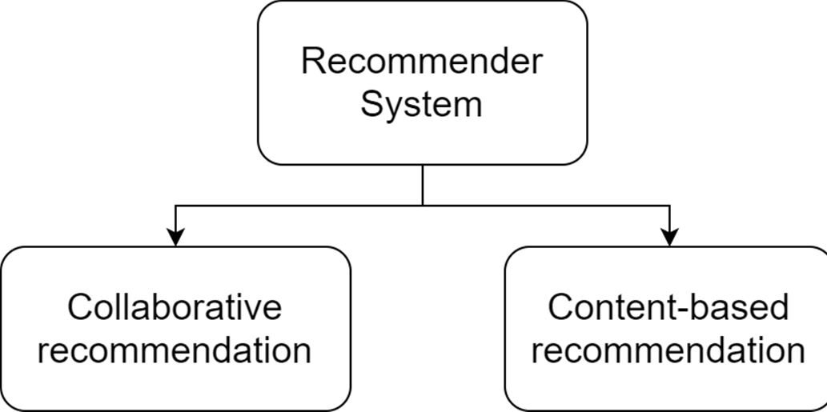

**Fig 1. Types of recommender systems**

* 1. **COLLABORATIVE RECOMMENDATION**

It is the most common technique used when it comes to building intelligent recommender systems that can learn to give better recommendations as more information about users is collected.

It is a technique that can filter out items that a user might like on the basis of reactions by similar users. It works by searching a large group of people and finding a smaller set of users. It then looks at the item they like and combines them to create a ranked list of suggestions. So to make Collaborative recommendation model we will use **KNN algorithm**.

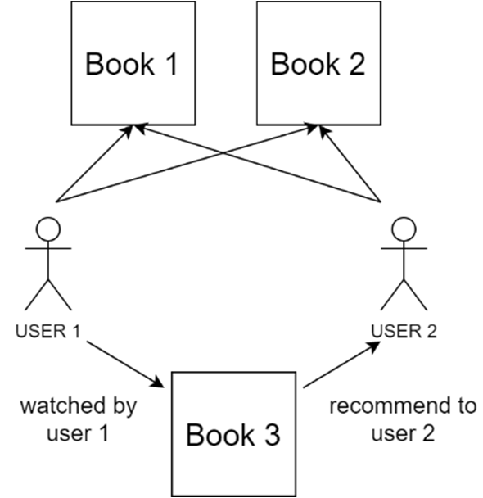

**Fig 2. Collaborative Recommendation**

* 1. **CONTENT-BASED RECOMMENDATION**

A Content-Based Recommender works by the data that we take from the user, either explicitly (rating) or implicitly (clicking on a link). By the data we create a user profile, which is then used to suggest to the user, as the user provides more input or take more actions on the recommendation, the engine becomes more accurate [2].

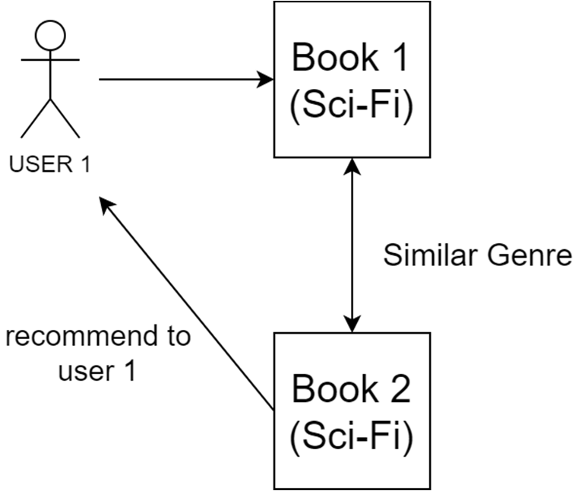

**Fig 3. Content-Based Recommendation**

This Recommendation System works on the principle of similar content. If a user is reading a book, the system will check about other books of similar content or genre that the user is reading. So, the idea is to tag products using keywords, understand what the users like, look up those keywords in the data and recommend different products with the same attributes. To check the similarity between the products, the system computes distance between them. For numeric data, **Euclidean distance** is used, for textual data **cosine similarity** or **TF- IDF** is used and for categorical data **Jaccard similarity** is used. So, in this project we have used **TF-IDF algorithm** to calculate the similarities between the books.

1. **EXPERIMENTAL SETUP**

For this project python programming language has been used, and in doing so, different frameworks and libraries provided by the python were also used and are listed below:

* **Jupyter Notebook**: Jupyter notebook is an open source web-application that supports interactive data science and scientific computing. It is used for Data Collection, Data Cleaning, Data visualization, Statistical models, Machine Learning and much more. It supports a variety of programming languages including python, R, Scala, etc.
  + **Django**: Django is an open source python library, that allows to quickly build highly interactive and customizable machine learning and data science web applications around the data.
  + **HTML Components**: For better UI purpose, to display HTML code or render a chart from a python visualization library.
  + **Tailwind CSS**: Tailwind CSS is a utility-first CSS framework for rapidly building custom user interfaces and designs. It is a great way to write inline styling and achieve an awesome interface without writing a single line of your own CSS.
  + **Pandas**: Pandas is a software library for python programming language, for data manipulation and analysis. It provides a fast and efficient way to manage and explore data, handling missing data, cleaning up data, merging and joining datasets, etc. It provides essential data structures like series, dataframes etc.
  + **NumPy**: NumPy is a python library, adding support for large, multi-dimensional arrays and matrices, along with large collection of high-level mathematical functions to operate on arrays.
  + **Chart.js**: Chart.js is an interactive and open-source plotting library for JavaScript.
  + **Scikit-Learn**: Scikit-Learn is a free software machine learning library for the python programming language, featuring various classification, regression and clustering algorithms including support vector machines, random forests, etc. and is designed to interoperate with python numerical and scientific libraries.
  + **Tweepy**: Tweepy is an open source python package that allows to conveniently access the Twitter API with python, it includes a set of classes and methods that represent Twitter’s models and API endpoints. It helps in extracting the tweets from Twitter
  + **TextBlob**: TextBlob is a python library for pre-processing textual data and provides a simple API for diving into common NLP tasks such as, part-of-speech tagging, noun phrase extraction, sentiment analysis, classification and much more.

1. **DATASET**

This project gives us a deep analysis on books dataset obtained from https://[www.kaggle.com/bahramjannesarr/goodreads-](http://www.kaggle.com/bahramjannesarr/goodreads-)

book-datasets-10m. These are multiple datasets containing information related to books and user rating such as book title, authors, language, average rating, publishing year, book description, etc. The datasets have been read into pandas data frames and have been combined together, data cleaning has been done on the combined datasets. In Fig 4. you can see the snippets of the Dataset used for analysis, recommendation.

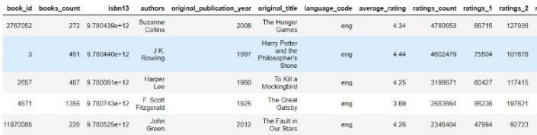

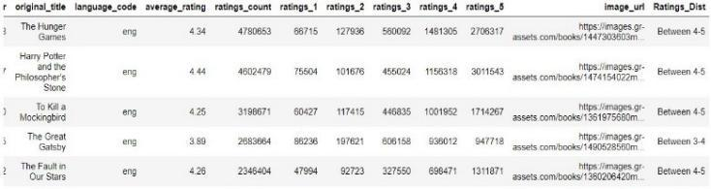

**Fig. 4: Dataset snippet**

1. **PROJECT PROCEDURE AND FLOW**

* We start by using Jupyter Notebook, where we use Pandas and NumPy libraries for collecting the data, handling missing data, cleaning the data and for performing various manipulation techniques.
* After preparing the data, we use Plotly python library for data analysis and visualization. Where we

represent the results in the form of various interactive charts and graphs, while making it easy to understand the trends and patterns in data.

* Now, we make use of the Scikit-Learn library for the recommendation system, by using the **KNN** algorithm for **collaborative recommendation** and **TF-IDF** algorithm for **content based recommendation** provided by the library.
* Next for **sentiment analysis**, we make use of Tweepy library to access Twitter API and extract tweets from Twitter and TextBlob library for preprocessing the extracted tweets. Also, make use of different methods functions provided by both the libraries for analyzing the sentiments of the tweets.
* After processing and analyzing the data in Jupyter Notebook, the next step is to integrate the code modules in the Django framework.
* For making UI more pleasing we make use of Tailwind CSS in HTML Components, without having to do any CSS coding.
* After everything is done, we integrate both the backend and frontend together and set our application running and working.



**Fig. 5: Procedure and Flow**

1. **TERM FREQUENCY – INVERSE DOCUMENT FREQUENCY (TF-IDF)**

It is a statistical measure that evaluates how relevant a

word is to a document in a collection of documents. It is calculated by multiplying two metrics : term frequency (TF) , that is how many times a word appears in a document and the inverse document frequency (IDF) of

the word across a set of documents.

So, the Term Frequency (TF) of a word in a document can be calculated by calculating a row count of instances of a word appearing in a document. The Inverse Document Frequency of a word across a set of documents which means how rare or common a word is in the entire document set. It is calculated by taking total numbers of documents, dividing it by the number of documents that contain that word. The closer it is to 0, the more common the word is. So if the word is very common and appears in many documents, this number will approach 0 otherwise 1. Now, multiplying these two metrics results in a TF-

IDF score of a word in a document. The higher the score is, the more relevant that word is in that particular document.

In Fig. 6 you can see the flow of TF-IDF algorithm.

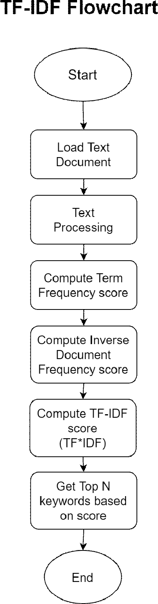

**Fig. 6: TF-IDF Flowchart**

1. **K NEAREST NEIGHBOR (KNN)**

The K-nearest neighbor is a simple, easy to implement supervised ML algorithm that can be used to solve both regression and classification problems. It assumes that similar things exist in close proximity. In other words similar things are near to each other.

It captures the idea of similarity sometimes called distance, proximity or closeness with some mathematics of calculating the distance between points on a

graph. Straight line distance, also called Euclidean distance is a popular and familiar choice.

The algorithm works as follows:

* + Load the data
  + Initialize K to chosen no. of neighbors
  + For each example in data calculate the distance between them.
  + Sort the ordered collections of distance from smallest to largest by distances
  + Pick the first K entries from the sorted collection.

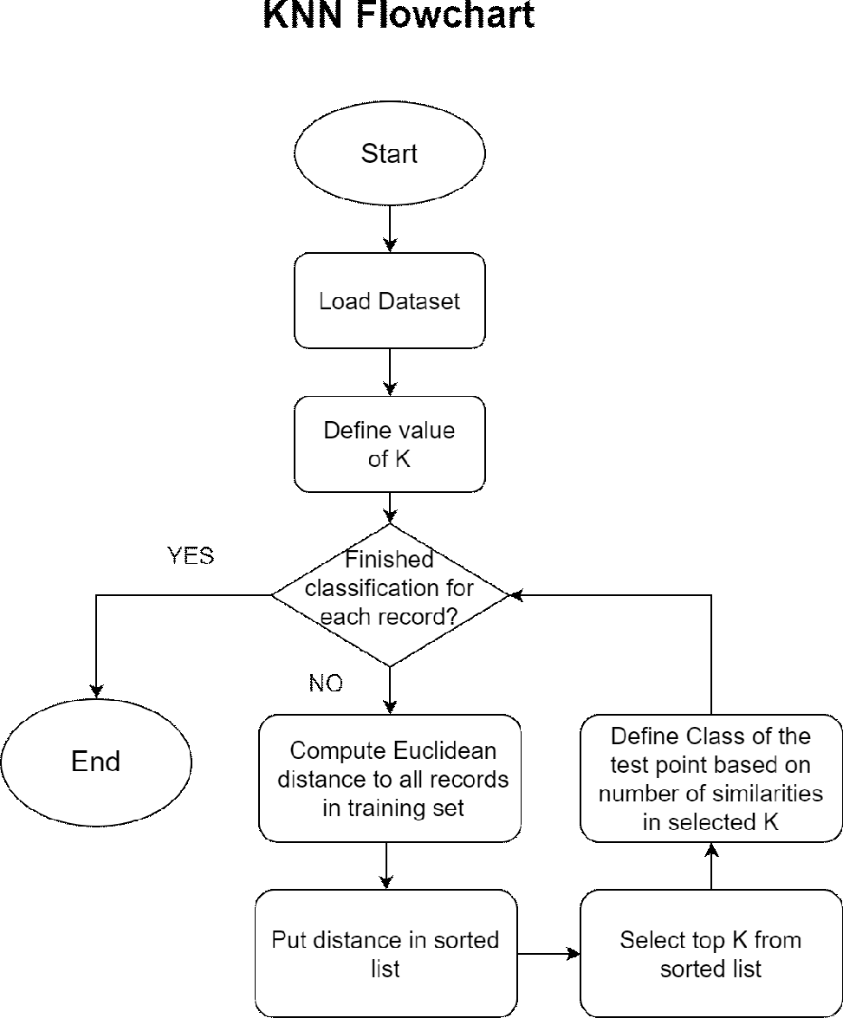

**Fig. 7: KNN Flowchart**

**Note:** to select the right K for our data, we need to run the algorithm with different values of K and choose the K that reduces the no. of errors and make accurate predictions.

1. **SENTIMENT ANALYSIS**

Sentiment analysis (or opinion mining) is a natural language processing technique used to determine whether data is positive, negative or neutral. Sentiment analysis is often performed on textual data to help businesses monitor brand and product sentiment in customer feedback, and understand customer needs.

For sentiment analysis, a text reviews dataset is used. Cleaning process is performed by using the re library. Polarity and Subjectivity are calculated and stored in new columns of the dataframe, you can see in Fig. 8. The percentage of the positive, negative and neutral reviews is calculated based on the polarity score, that is, if the polarity is greater than 0, the review has positive sentiment, if it is less than 0, then the review has negative sentiment, otherwise the review is neutral.

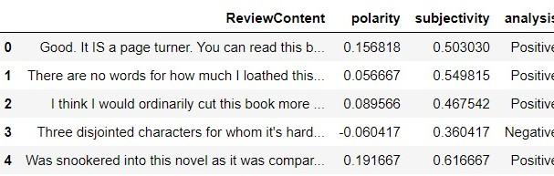

**Fig. 8: new Dataframe**

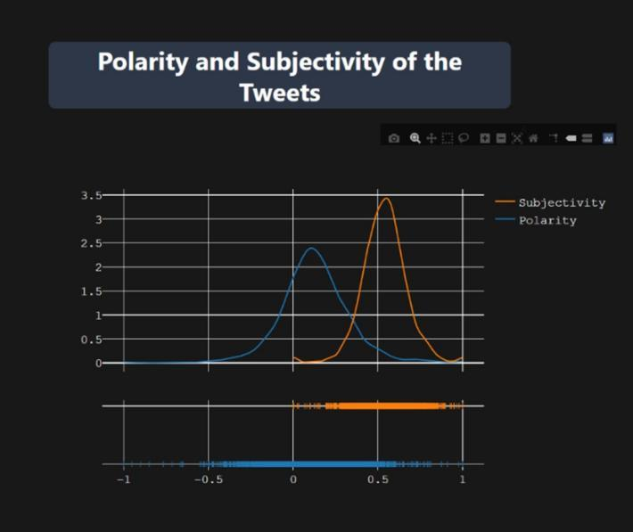

**Fig. 9: Polarity and Subjectivity of Tweets**

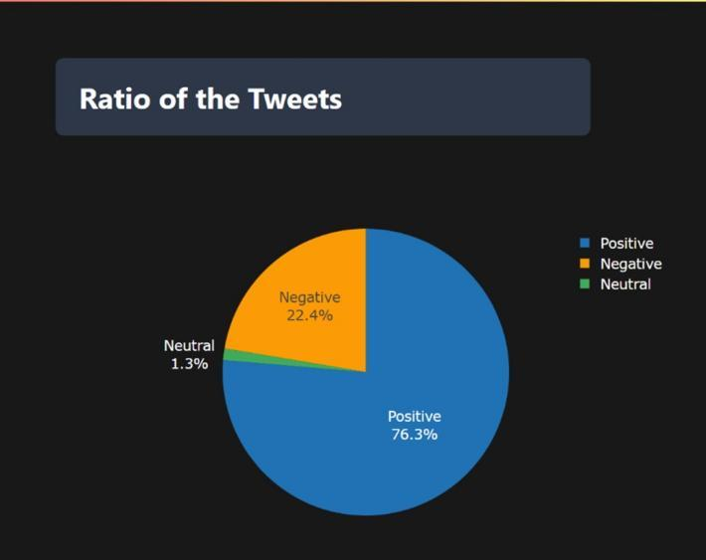

**Fig. 10: Ratio of Tweets**

1. **LIMITATIONS**

This project does not work on user login basis, so that the user can log in and directly get the suggestions based on the user’s reading, and review history without having to type the book name to get recommendations.

1. **SIGNIFICANCE OF RESEARCH**

The whole purpose of this research is to make reading books easier for the readers, and recommend books with just a click. To present visualizations regarding

reviews, books, authors, such as trending books and authors.

**12. CONCLUSION**

As from the research we understood that, people are moving more towards reading books online, as it saves time of going and buying the books physically.

From the datasets used for this project, we made some observations. First of all the dataset contains books from a wide range of years, with a wide range of authors and also the users of different age groups. We can conclude that most of the books receive ratings between 3-5, and most of them are the books published in English language. We can also see the books published over the years, with 2011 being the one with the highest number of books published.

For users we can say that most of the active users are between the age group of 31-50, almost 49.5%. Also teenagers are not into reading books as they have the lowest percentage in the user dataset. We can also conclude that most of the active users are from different states and cities of Canada with almost 78.3%. Lastly, from the sentiment analysis we can conclude that most of the users are having positive reviews regarding the books as the polarity of most the reviews is more between 0-1 and we can also see that almost all reviews are subjective.

**11. FUTURE RESEARCH**

* Future Research includes making the UI based on user login, so that the user can directly view the recommendations based on their reading history and the ratings given by the user for particular books, also the prediction of the unread books.
* Presenting sentiment analysis for a specific book by live scraping the tweets related to that book, so that the user can see and compare between two or more books.

**REFERENCES**

1. Deuk Hee Park, Hyea Kyeong Kim, Il Young Choi, Jae Kyeong Kim, “A literature review and classification of recommender systems research”, Volume 39, Issue 11, 2012, Pages 10059- 10072, ISSN 0957-4174
2. Brooke, Julian, Milan Tofiloski, and Maite Taboada. "Cross- linguistic sentiment analysis: From English to Spanish." Proceedings of the international conference RANLP-2009. 2009.
3. P. Turney. Thumbs up or thumbs down? Semantic orientation applied to unsupervised classification of reviews. Proc. of ACL, 2002.
4. B. Pang, L. Lee and S. Vaithyanathan. Thumbs up? Sentiment classification using Machine Learning techniques. Proc. of EMNLP, 2002.
5. Yugantshekhar, “ML- Content Based Recommender System”, geeksforgeeks.org



**Fig 16.1 – Yash Brid’s Certificate**



**Fig 16.2 – Prem Chawla’s Certificate**





**Fig 16.3 – Kapil Bhavnani’s Certificate**



**Fig 16.3 – Vaishnavi Bidoo’s Certificate**

